Subject: Taking Round Up to the Next Level

Hi Team,

The Taco Bell Foundation’s E11 Round Up Sprint is on from October 16 – November 19, and your restaurant has a chance to shine! The goal? Improve your Drive-Thru Donation Acceptance Rate (DAR%) from E10 by asking every customer to Round Up — every “yes” counts.

Prizes include exclusive backpacks, premium water bottles, and the first-ever Sprint Trophy for the owner with the highest overall improvement.

How to win: Be one of the top 180 restaurants (30 per region) with the biggest DAR% improvement from E10, or have the top DAR% overall, and help contribute to the organizations cumulative DAR%!

Rewards:
Top 180 restaurants  (30 restaurants per region) w/ greatest DAR% improvement | Top 10 restaurants  w/ the highest overall DAR% | Franchise  w/ top DAR improvement
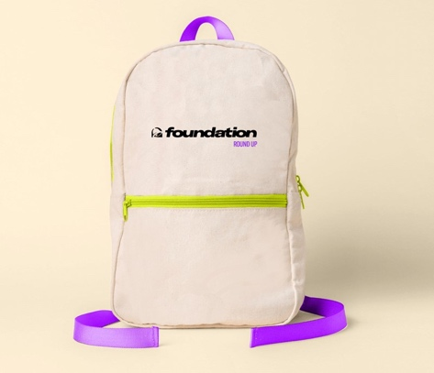​  Exclusive Foundation Backpack | 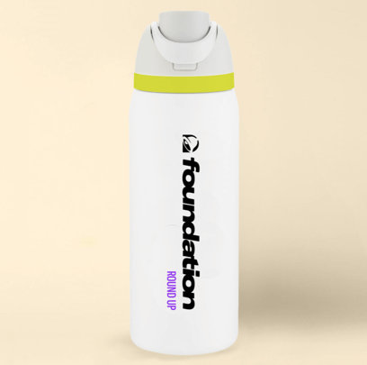​Foundation Water Bottle | 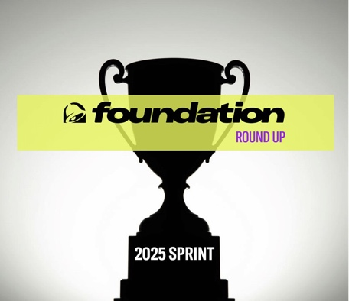​E11 Sprint Trophy
A Few Tips:
- Ask every time: “Would you like to round up to support students?”
- Practice in huddles so it feels natural.
- Normalize hearing “no” — The more you ask, the more success you'll see.
- Check out this video to learn more about DAR.
Your energy powers this movement. Let’s make every ask count and show how together we can make a big impact! ​

