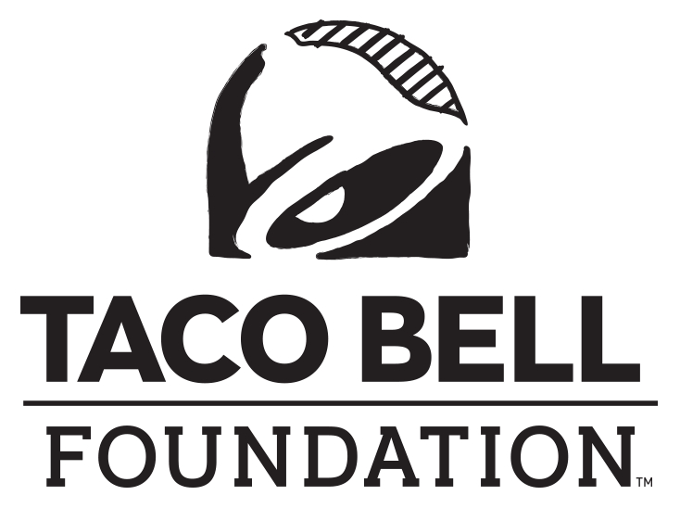 [Organization Logo]

FOR IMMEDIATE RELEASE

Contact: [Name], [Title]
[Organization]
[Email]

LOCAL [community NAME] [ORGANIZATION] AWARDED [$xx] TO fuel [CITY/COUNTY] YOUNG PEOPLE’s bold ambitions

[City, State] (Month Day, 2023) – Today, [organization] received a [$XX] grant from the Taco Bell Foundation to support more than [#] youth in the [community name] community. The funds will go toward [brief description of services, i.e., career/college prep sessions, mentoring, providing resources, etc.] and other programs that educate and inspire the next generation of leaders.

“It’s a privilege to partner with the Taco Bell Foundation in educating and inspiring young people nationwide,” said [representative’s name], [representative’s title] of [organization]. “Together, we are working to break down barriers to education for future leaders.”

[Organization] is one of more than 450+ youth-serving organizations that will receive a portion of the $15 million in Community Grants presented by the Taco Bell Foundation this year. The grants are an example of the Taco Bell Foundation’s mission to break down barriers to education and fuel young people’s boldest ambitions.

“We are proud that the work we do through our Community Grants program connects young people with the resources and opportunities they need to learn and drive change,” said Jennifer Bradbury, Executive Director of the Taco Bell Foundation.

About the Taco Bell Foundation
Taco Bell Foundation, Inc. is a 501(c)(3) tax-exempt public charity that educates and inspires the next generation of leaders through programming like the Live Más Scholarship and the Local Grants Program. Since 1992, the Taco Bell Foundation has reached more than 5 million young people across the country and has awarded more than $150 million in grants and scholarships, focused on education and career readiness. In 2015, Taco Bell and the Taco Bell Foundation launched the Live Más Scholarship, a program aimed at fueling the bold ambitions of America’s future leaders. In May 2023, the Taco Bell Foundation awarded $10 million in Live Más Scholarships to over 900 students. For more information, visit TacoBellFoundation.org.

[INSERT ORGANIZATION BOILER PLATE]

###

